Ti Tans Bank KYC System – Database Design (Logical & Physical)
This document presents the complete Database Design for the Ti Tans Bank KYC System. It includes the Entity Relationship (ER) Diagram, Logical Database Design, and Physical Database Design derived from the provided schema.

Entity Relationship (ER) Diagram
The ER diagram below illustrates all core entities, attributes, and relationships used in the KYC system.
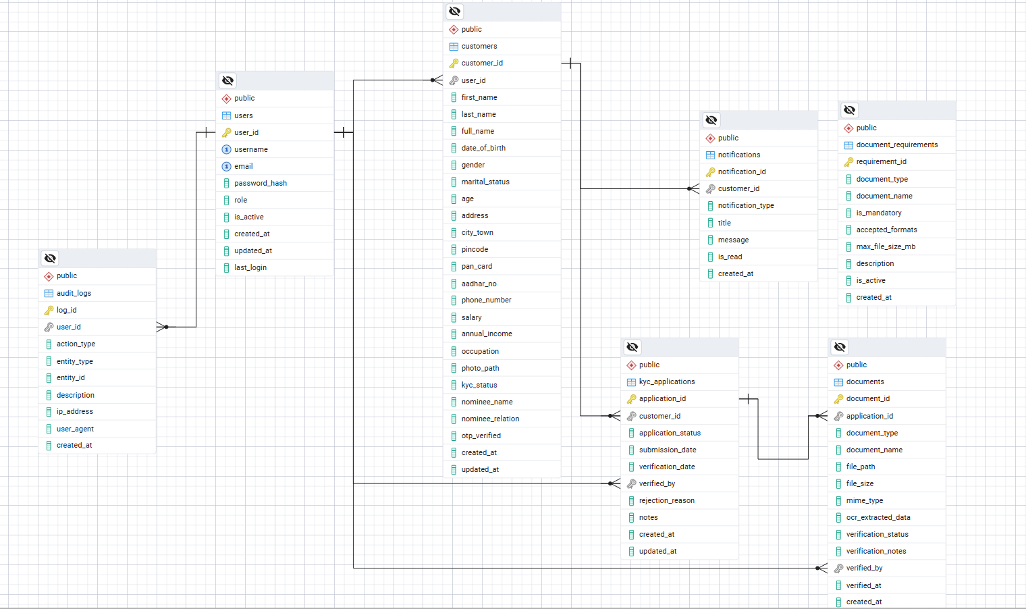

Logical Database Design
The logical design defines entities and relationships independent of physical implementation.
Users: Stores system user accounts, authentication, and authorization details.
Customers: Stores customer personal, identity, and KYC-related information.
KYC Applications: Tracks KYC application lifecycle and verification status.
Documents: Stores uploaded documents and OCR verification data.
Document Requirements: Defines mandatory document rules and constraints.
Notifications: Stores notifications sent to customers.
Audit Logs: Captures system activity for auditing and compliance.

Entity Relationships
- One User → One Customer
- One Customer → Many KYC Applications
- One KYC Application → Many Documents
- One Customer → Many Notifications
- Users perform verification actions on Applications and Documents
- Audit logs track user activities across entities

Physical Database Design (PostgreSQL)
The physical design specifies table structures, keys, and storage details.

USERS
- user_id (PK)
- username (UNIQUE)
- email (UNIQUE)
- password_hash
- role
- is_active
- created_at
- updated_at
- last_login

CUSTOMERS
- customer_id (PK)
- user_id (FK)
- first_name
- last_name
- full_name
- date_of_birth
- gender
- marital_status
- age
- address
- city_town
- pincode
- pan_card
- aadhar_no
- phone_number
- salary
- annual_income
- occupation
- photo_path
- kyc_status
- nominee_name
- nominee_relation
- otp_verified
- created_at
- updated_at

KYC_APPLICATIONS
- application_id (PK)
- customer_id (FK)
- application_status
- submission_date
- verification_date
- verified_by (FK users)
- rejection_reason
- notes
- created_at
- updated_at

DOCUMENTS
- document_id (PK)
- application_id (FK)
- document_type
- document_name
- file_path
- file_size
- mime_type
- ocr_extracted_data
- verification_status
- verification_notes
- verified_by
- verified_at
- created_at

DOCUMENT_REQUIREMENTS
- requirement_id (PK)
- document_type
- document_name
- is_mandatory
- accepted_formats
- max_file_size_mb
- description
- is_active
- created_at

NOTIFICATIONS
- notification_id (PK)
- customer_id (FK)
- notification_type
- title
- message
- is_read
- created_at

AUDIT_LOGS
- log_id (PK)
- user_id (FK)
- action_type
- entity_type
- entity_id
- description
- ip_address
- user_agent
- created_at

